What is higher-order learning and thinking?
Understanding 'expertise'
The goal of every learner is to develop expertise. Expertise means you can answer any question and solve any problem. However, an expert's "knowledge structure" or "knowledge network" (i.e. how they have organised information in their brain) is different to that of a novice.
To understand what knowledge structures look like for experts, we can consider Bloom’s revised taxonomy below.
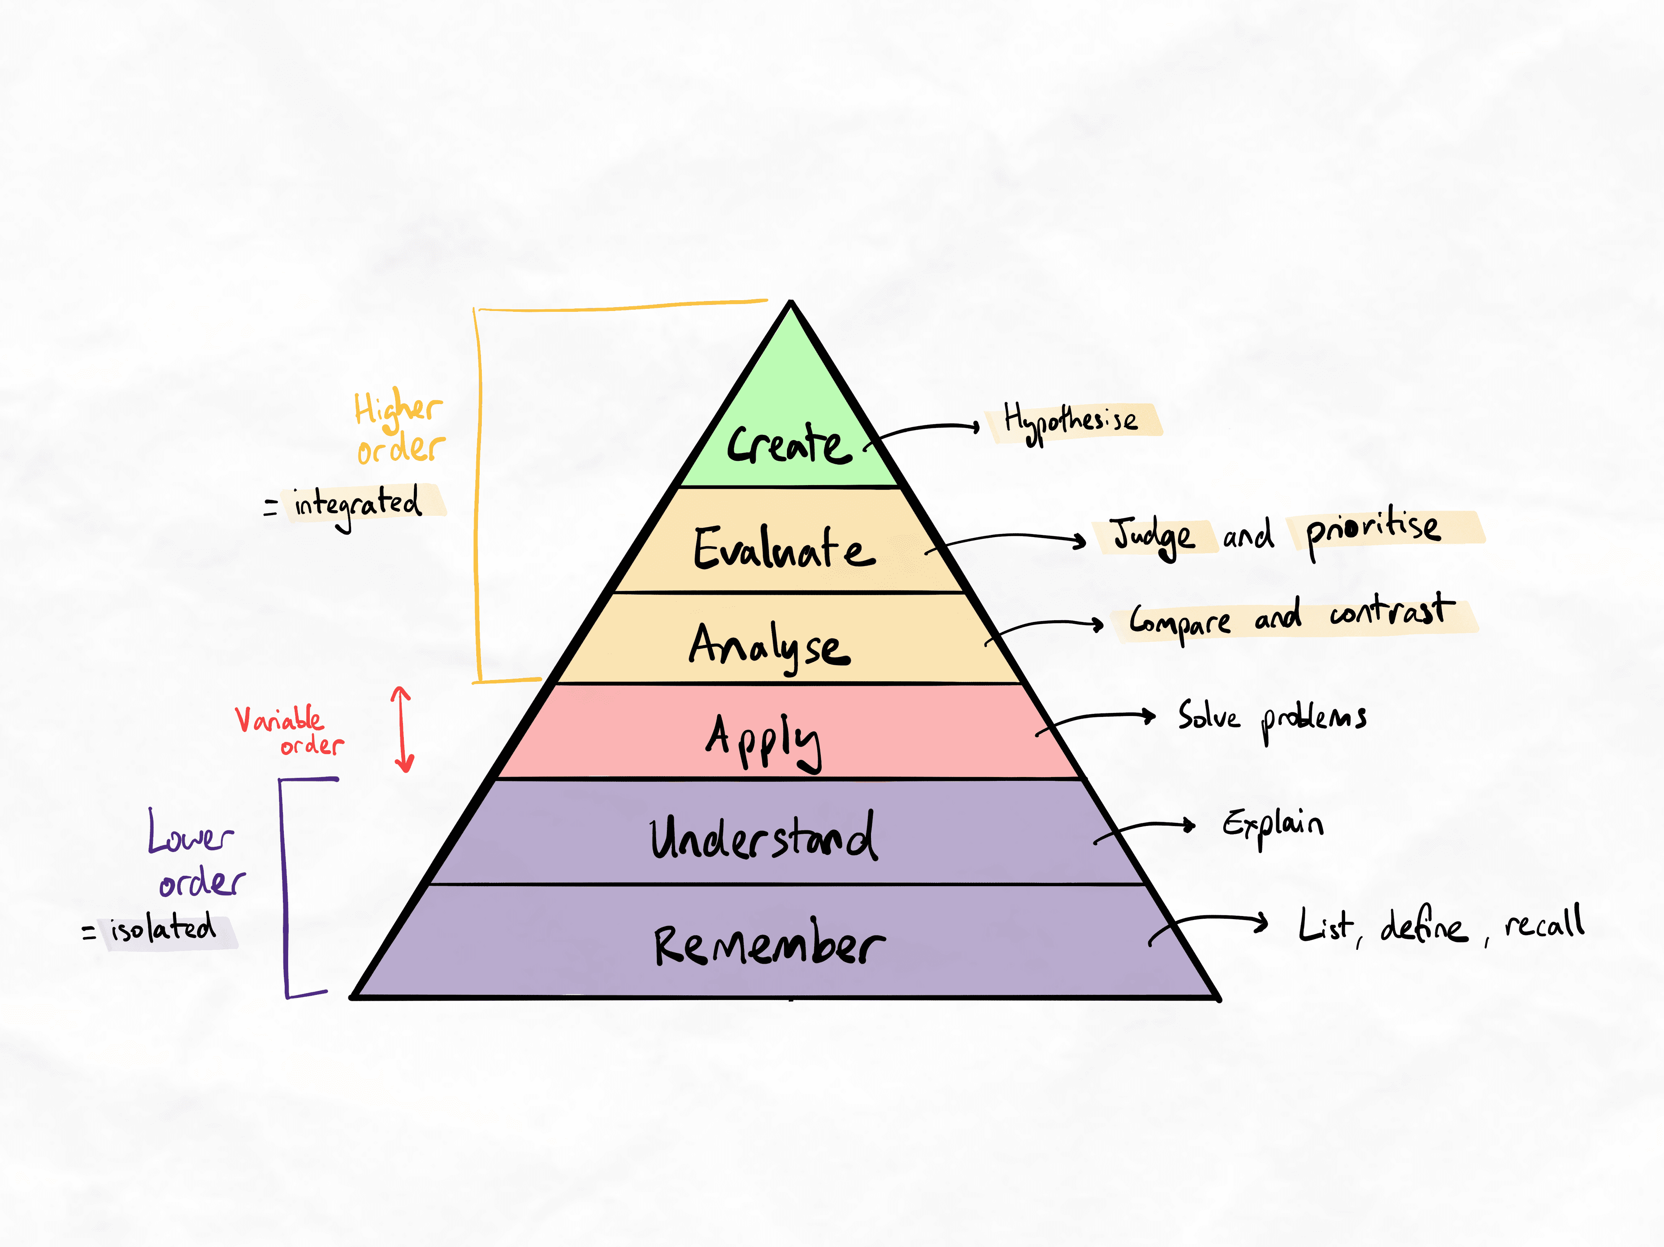
Bloom's revised taxonomy, divided into higher-order and lower-order learning.
Key principles of higher-order vs. lower-order learning
- Higher-order knowledge is integrated in a network. Lower-order knowledge is isolated.
- Integration occurs by analysis and evaluation (comparing information and making judgments on their relative importance).
- Higher-order learning is beneficial for retention and depth of understanding. Lower-order learning is forgotten quickly and easily.
Higher-order learning as a process vs. an outcome
Orders of learning can be considered both processes and outcomes. This is important because higher-order learning processes lead to higher-order learning outcomes, but not vice versa.
For example
Suppose someone compares ideas to find ways to group information (analyse), then makes a judgment on the relative importance of each group to map them out (evaluate). They will have created higher-order knowledge. With retrieval practice to refine and consolidate their learning, they will be able to retrieve at higher orders since the information is organised in the right way.
On the other hand, lower-order learning processes lead to lower-order learning outcomes.
For example, if someone uses flashcards to memorise lists of facts, they will be able to retrieve their knowledge at this level with sufficient repetition.
The crucial difference
There are some crucial differences between using higher-order learning methods vs. using lower-order methods.
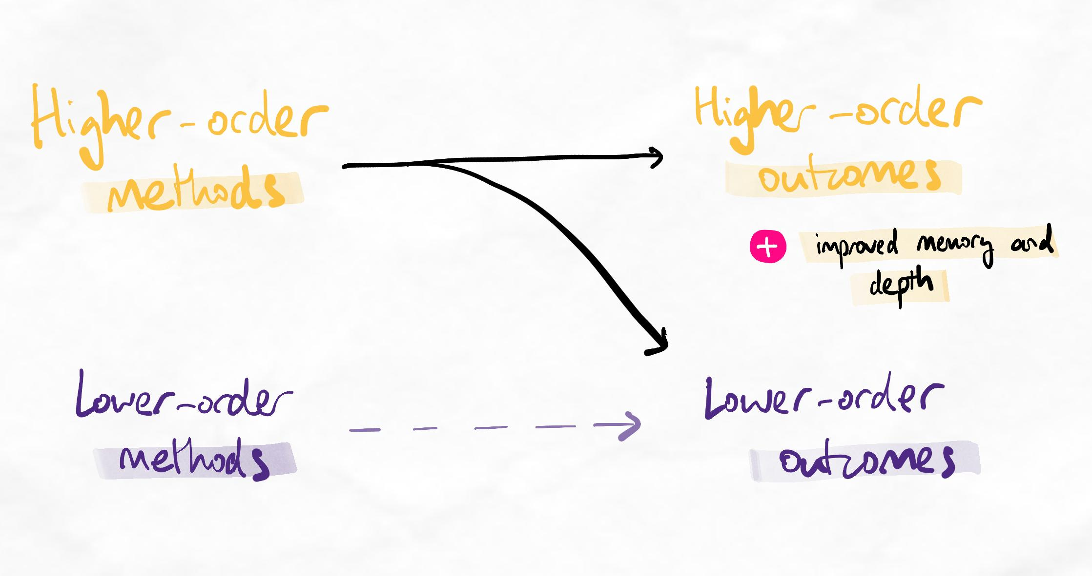Higher-order methods are generally advantageous to lower-order methods.
- Higher-order learning methods produce both lower-order and higher-order knowledge. This is because it is impossible to compare ideas without understanding them first. Lower-order only produces lower-order knowledge.
- Starting with a higher-order method is more efficient than starting with lower-order methods. This is because higher-order methods build networks of knowledge, which makes information more memorable to begin with. This reduces how much you need to memorise with lower-order methods. We call this reducing your lower-order burden.
- You always need multiple orders of learning in your methods. Even though higher-order learning creates more robust knowledge, the human brain always forgets. Retrieval practice is needed to ensure that we can perform at all necessary orders of learning.
An alternative view of learning and expertise
As higher-order methods of thinking help form better memory and expertise across all levels, another way of thinking about learning is that memory and understanding are outcomes. This contrasts with Bloom's taxonomy, which represents these two as the bottom levels of learning in what seems like a hierarchy.
However, this is inaccurate based on the latest research, and scholars criticise Bloom's for this reason. Instead, the diagram below shows how engaging in cognitively beneficial thinking processes produces better memory and understanding.
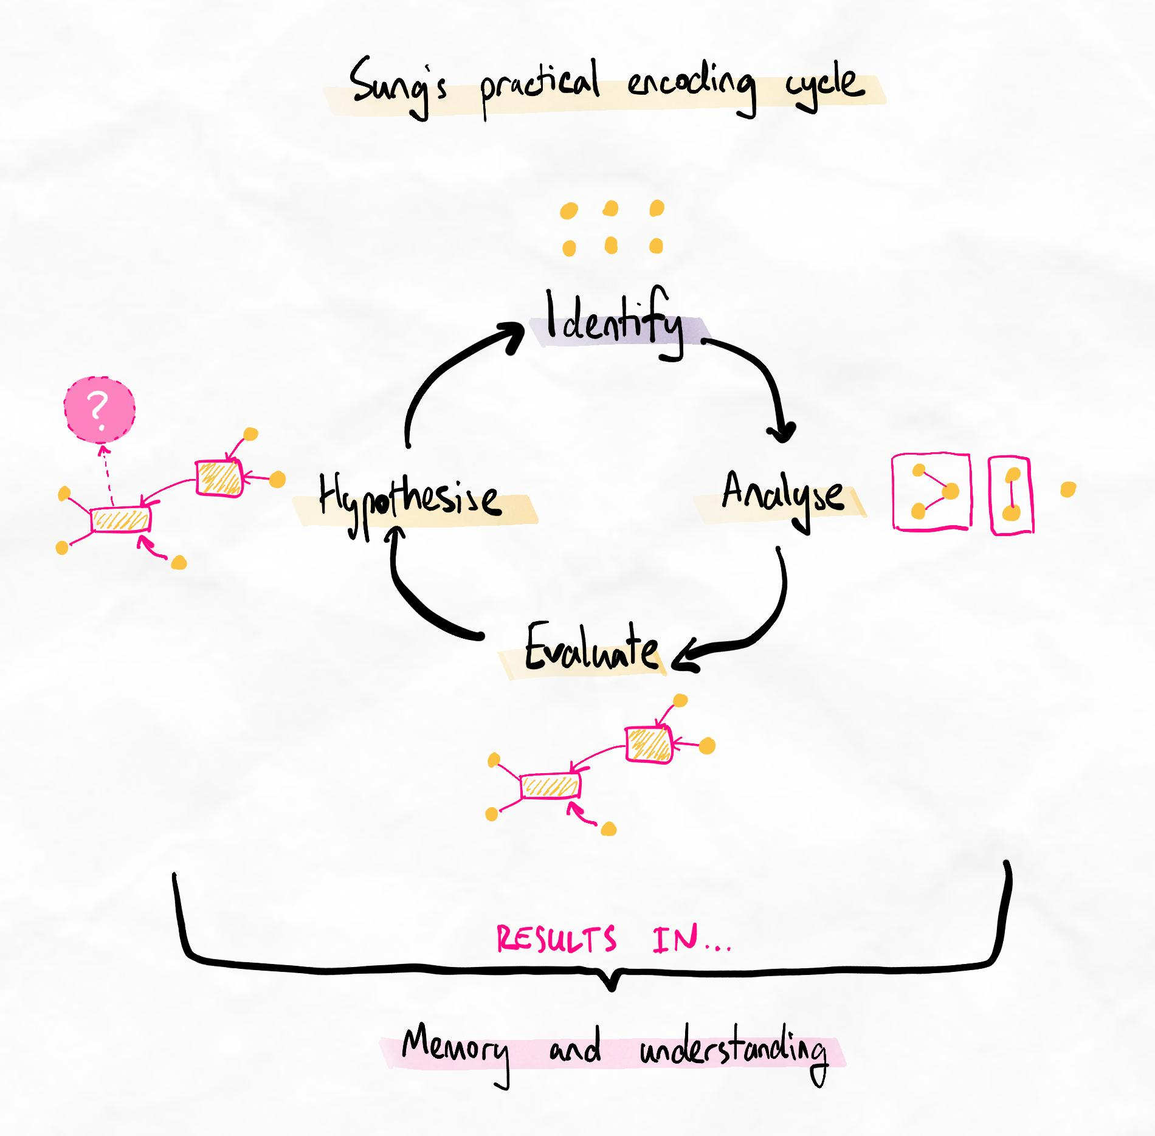
In this model, we see that memory and understanding results from a cycle of higher-order thinking.
This is also an oversimplification of learning (which is extremely complicated, by nature). However, it is a more accurate depiction of learning and developing expertise.
In summary
- Higher-order thinking involves comparing, finding trends and similarities, grouping, simplifying, making judgments on importance and relevance of information, and relating information to the big picture.
- Lower-order thinking is isolated and involves repetition.
- These processes were famously described by Benjamin Bloom but have been challenged by researchers since then.
- Expertise requires higher-order mastery, which is created with higher-order thinking. Lower-order thinking is very bad at creating expertise.
- Higher-order thinking creates improved memory and depth of understanding, therefore, we should endeavour to engage in higher-order thinking and learning often.
What does higher-order learning feel like?
Learning happens in the brain. We can’t see it with our eyes. Therefore, it’s important that you mentally know what higher-order learning feels like so that you can start monitoring if you’re using the right processes.
Higher-order learning | Lower-order learning
Involves comparing, contrasting, evaluating, and forming networks and relationships. | Involves rote-memorising, repeating, and trying to understand information in isolation (without comparing and creating networks).
Feels challenging, mentally effortful, and potentially confusing. Learners often go back and forth between their material and spend lots of time thinking deeply and asking questions. | Feels tedious, time-consuming, mentally straightforward, and potentially boring or sleep-inducing.

